
Dunwich Beach Fish and Chip run

Start at Six Mile Bottom 10am Sunday 15th of March. Approx route:

10:00 depart Green Man, Six Mile Bottom, CB8 0UF
10:10 Great Bradley
10:30 Dalham
11:05 Burthorpe
11:10 Risby
11:20 West Stow
11:30 Troston
12:10 Rishangles
12:30 Heveningham
13:00 Dunwich Beach IP17 3EN (all plus or minus 10 mins)

Google map of route

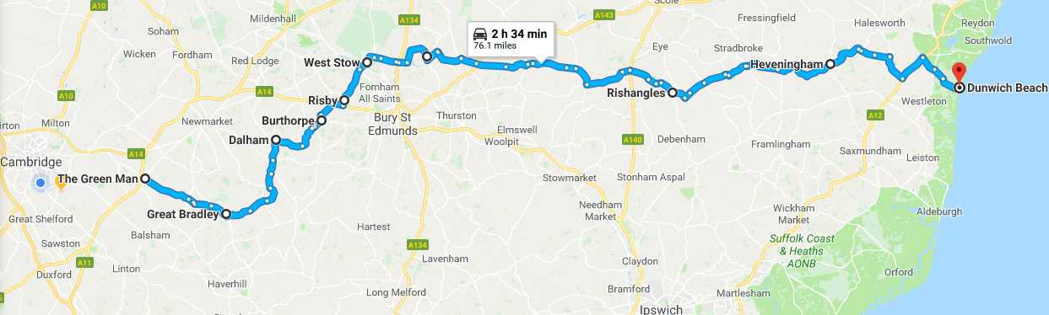

Lunch on the beach at Flora Tearooms from 1pm

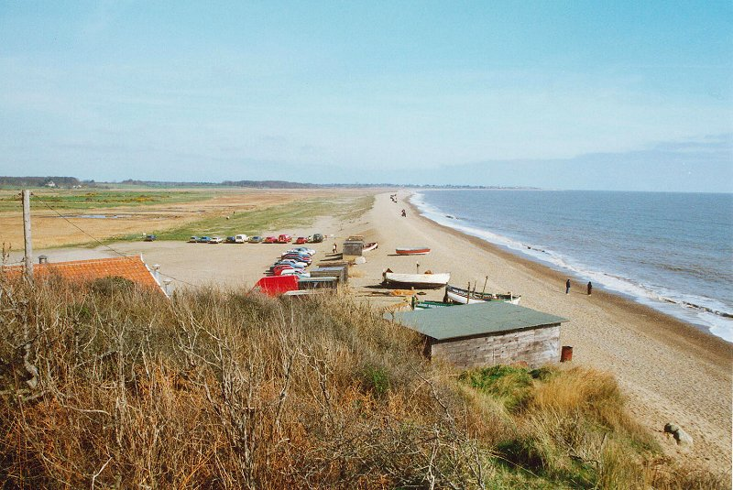

Leisurely drive home

Tom
07795 436149

